Teal Engineering Services Ltd
Trabboch
By Stair
Ayrshire
KA5 5HT

Telephone: 01292 811955
Fax: 01292 811295

info@teal-es.co.uk
www.teal-es.co.uk

Teal Combi Trailer

Handover advice from Geoff Turner

- Load trolley and boat onto trailer:

  - For first load, the Front and Rear bunk legs will need adjusting. Loosen the clamps to allow the bunks to fit the profile of the hull once in place.

  - Once in use, loosen rear clamps only to allow trailer bunks to lower slightly. This will aide loading and unloading.

  - Ensure trailer is hitched to tow vehicle or wheels chocked and brake on (upright)

  - Do Not leave the trailer hand brake on for long periods, chock the wheels instead. This will prevent the brakes from seizing.

  - Offer up trolley and boat to line up trolley longitudinal shafts with red cupped wheels at rear of trailer and keel of boat with rear roller of trailer.

  - Clip the winch strap to the trolly handle, winch the boat and trolly on to the trailer, stop winching just before the trolly jockey wheel gets to the back of the trailer.

  - Remove the Jockey wheel yoke from the shafts of the launch trolley (tip leave the jockey wheels sitting under the trailer)

  - Continuing winching the trolley onto trailer
    - take care to keep keel aligned with trailer rollers
    - assist trolley and boat to rise up over each roller in turn as weight is transferred from trolley to trailer
    - continue winching until boat stem is snug in jaws of winch post
    - secure winch hook and lock off

  - For first load, adjust winch post and centre of gravity of load fore and aft to achieve 60kg nose weight on the tow hitch when laden. (Use bathroom scales).

  - With the boat loaded, use the two lugs on the rear of the trailer for clamping the trolley jockey wheel yoke for transport with the boat, NOT TO BE FORGOTTEN.

  - Load and secure oars, rudder and gear, distributing weight evenly along length of the boat.

  - Secure boat to trailer with strong back and/or ratchet straps, hooked into eyes on trailer chassis. Do not over-tighten ratchet straps! Use steps on wheel mudguards., if required.

  - Secure trolley to trailer with short straps to reduce movement and rattles.

  - Fit boat cover if necessary.

  - Hitch trailer to tow vehicle with safety chain and raise jockey wheel.

  - Fit rear light board to trailer arms, adjusting length of overhang for the boat. Mark positions first time. Plug light board cable into socket at rear of trailer, and cable to tow vehicle. Use a strap or rope from the lights board over the back of the boat to stop the light board from bouncing while in transit.

  - Ensure red breakaway cable is hooked to tow vehicle bracket. (DO NOT loop over tow ball)

  - Remove chocks and release handbrake (down).

  - Fit registration plate to clip on brackets on light board.

  - Check all lights, jockey wheel, secure fixings, clamps and straps.

  - IT IS THE RESPONSIBILITY OF THE DRIVER TO ENSURE THAT THE LOAD IS SAFE

- Unloading boat for launching or storage with launch trolley.
  - This is largely the reverse of the loading process with special attention to:
  - Remove light board, all straps, attachments etc.
  - Loosen the rear bunk supports
  - Push the trolley WITH the boat over and down the rollers, not just pushing the boat.
  - Ensure no one is at risk from a spinning winch handle by removing it first.

- Carrying the boat on the trailer alone without the trolley.
  - Can be done using the rear roller on the trailer to guide the boat on. It will need steadying until winched forward to where the bunks stop the boat rolling sideways.

- Carrying the trolley without the boat.
  - Winch as for loading the boat or lift on.
  - Use the winch hook and strap to secure the handle to the winch post.

Photos

- Combi Trailer & Trolley
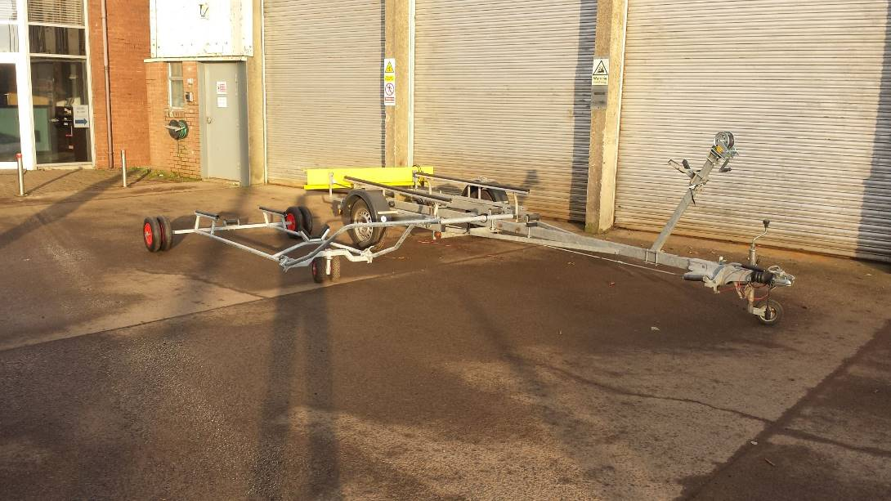

- Lining up the trolley with the trailer Guide Rollers

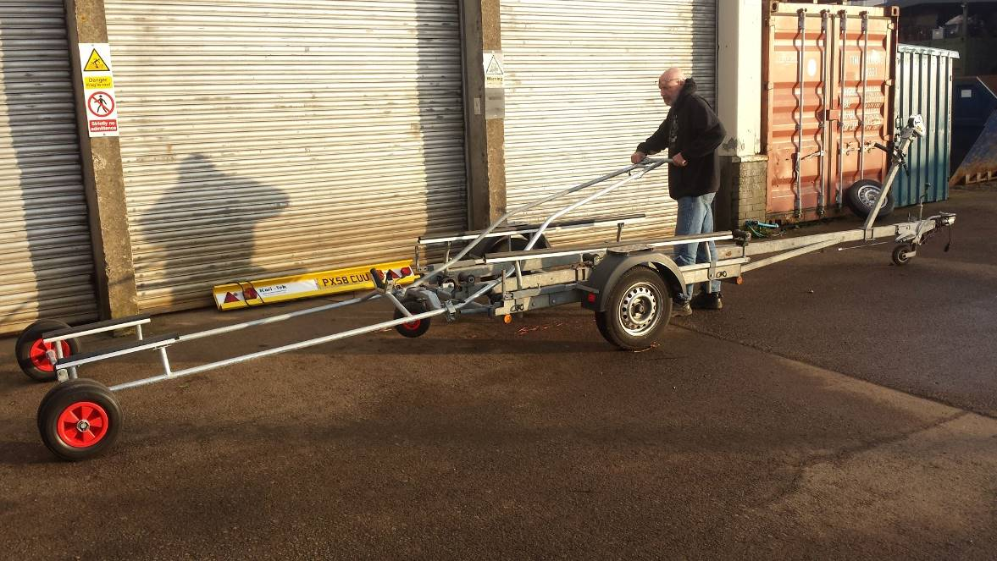

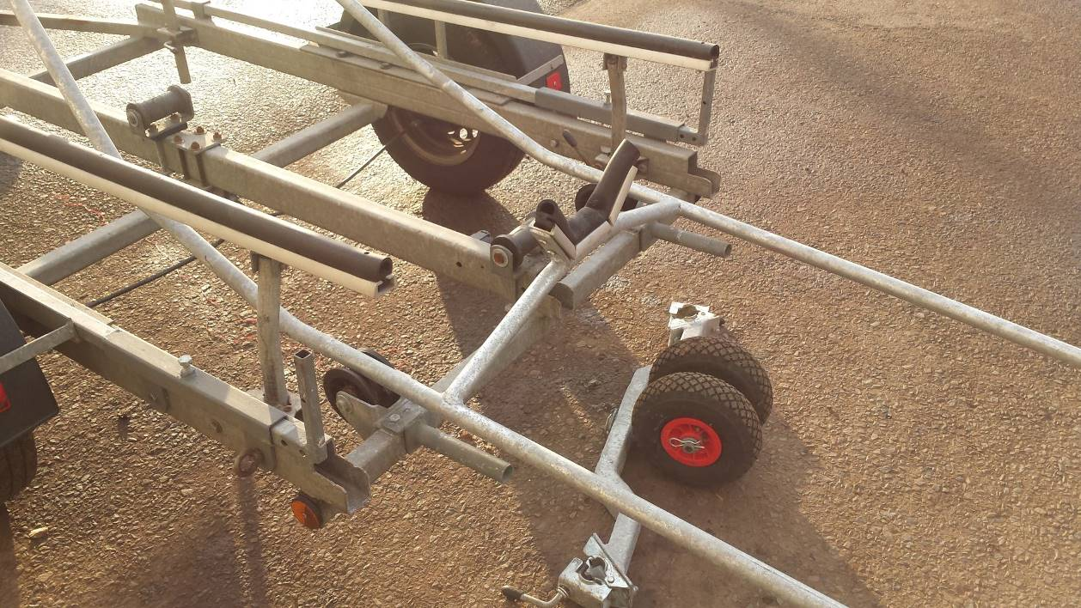
- Detach the Jockey Wheel Cross member

- Pull the trolley onto the trailer, with the skiff on the trolley this is made easier using the bow post winch

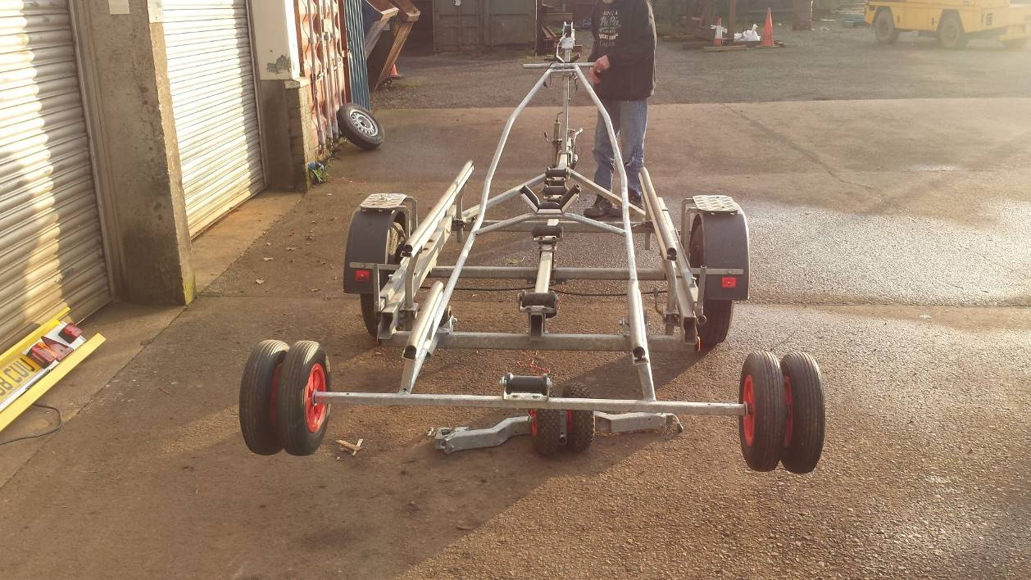

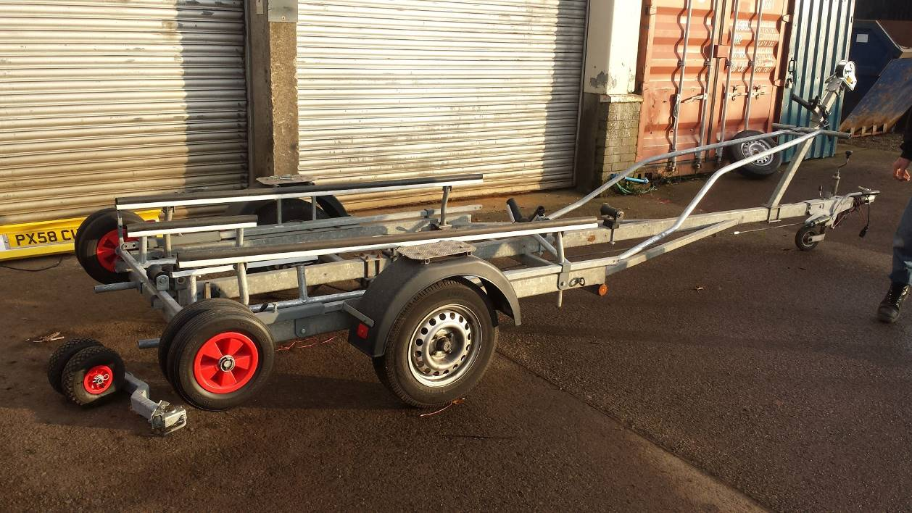
- Trolley loaded onto the trailer

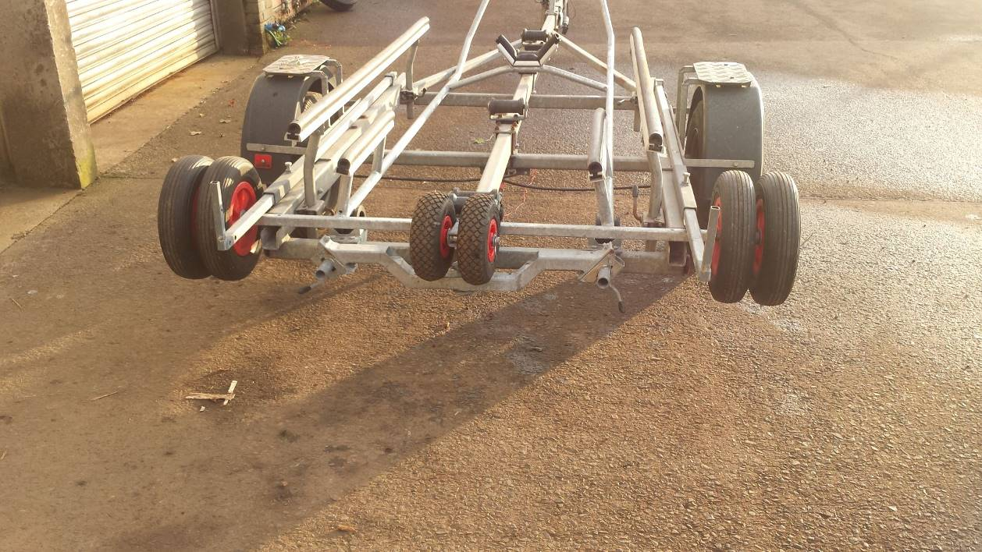
- Stow the trolley Jockey Wheels and cross member on the carry tubes at the back of the trailers

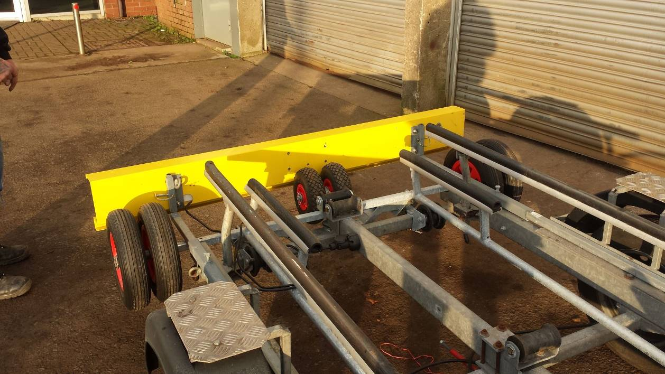
- Light board attached. Trailer is ready to go

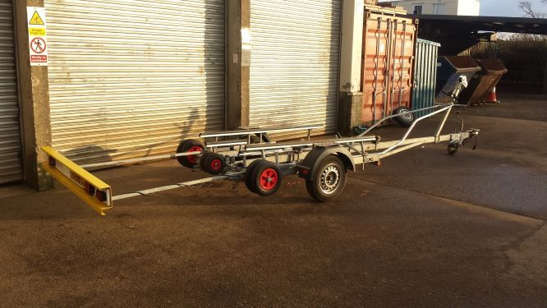
- Light board fully extended

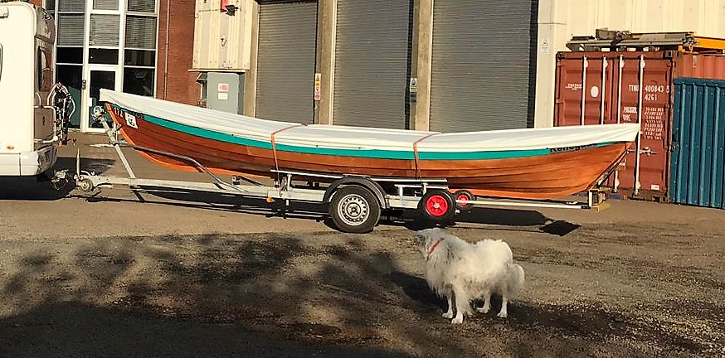
- All loaded up the Skiff is now fully supported on the road Trailer, the Jockey Wheels sit either side of the Skiff Keel.

